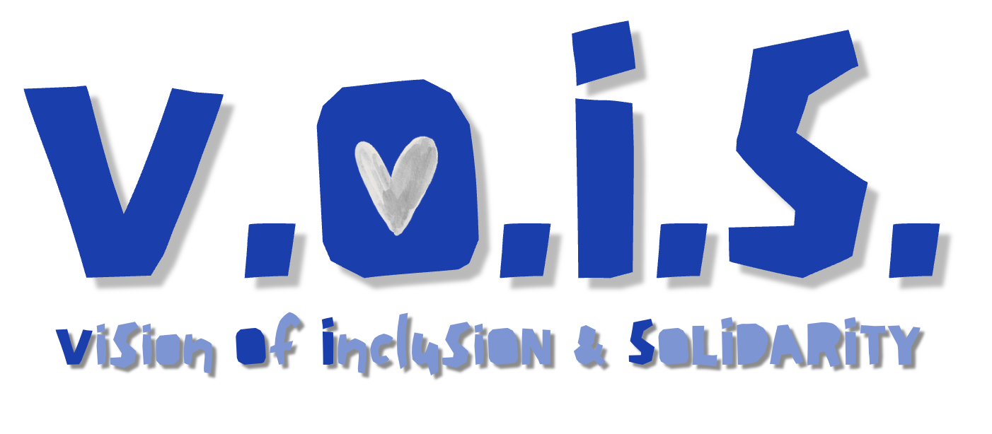


PARTICIPANT ENROLMENT FORM

This form must be typed and emailed to info@turcostaposibel.eu with the subject line “VOIS Application.”

PERSONAL DATA
(If names are given incorrectly, you will be charged to amend your flight booking – please give names as on your passport – you will need a passport, not an ID card, to travel)
YOUR PHOTO

FIRST NAME:

SURNAME:

GENDER:

DATE OF BIRTH:

AGE (you MUST be 23+):

NATIONALITY:

PASSPORT NUMBER:

PASSPORT EXPIRY DATE:

PLEASE SEND A COPY OF YOUR PASSPORT with your application in the email!

ADDRESS (in full, including town and postcode):

TELEPHONE:

E-MAIL:

For all young people applying to be a European Solidarity Corps volunteer

European Solidarity Corps NUMBER:
(We cannot process your application without this, and we will not reply. You must register online to become an ESC volunteer https://youth.europa.eu/solidarity/young-people/volunteering_en):

Emergency contact name:

Phone number of emergency contact:

Email address of emergency contact:

Relationship to contact:

Sending Organisation registered with a Quality Label to support volunteers in your country of origin:

For ESC TEAM projects, it is not mandatory to have a sending organization. However, if you have one, please write it here.

NAME OF ORGANISATION:

ADDRESS (in full, including town and postcode):

OID NUMBER:

CONTACT PERSON:

TELEPHONE:

E-MAIL:

ABOUT YOU

SKILLS: Which of the following skills or experiences do you have? Put an X next to the skill you have.

☐ Photography
☐ Cooking
☐ Art, painting, clay, drawing, etc. (Specify)
☐ Music
☐ Hip-hop/ rap
☐ Skateboarding

If you have other skill that could be relevant to this project, please specify.

LANGUAGE/S SPOKEN:

DO YOU HAVE A DRIVING LICENCE?

WOULD YOU BE HAPPY TO DRIVE OVERSEAS?

CAN YOU CHANGE A CAR TYRE?

CAN YOU RIDE A BIKE?

CAN YOU FIX A PUNCTURE?

DO YOU HAVE ANY DIETARY OR MOBILITY REQUIREMENTS?

DO YOU SMOKE?

DO YOU DRINK ALCOHOL?

IF SO, HOW MANY UNITS A WEEK?

WHICH OF OUR ESC PLACEMENTS ARE YOU INTERESTED IN?

WHEN ARE YOU AVAILABLE TO BEGIN YOUR VOLUNTARY SERVICE?

WHAT IS YOUR PREFERRED DURATION OF PLACEMENT?

DUE TO THE HIGH COSTS OF ACCOMMODATION, VOLUNTEERS WILL SHARE A ROOM – IS THIS OK FOR YOU?

HOW WOULD YOU DESCRIBE YOURSELF? (VALUES, STRENGTHS, AND WEAKNESSES)

HAVE YOU UNDERTAKEN AN INTERNATIONAL PROJECT BEFORE? IF SO, WHAT WAS IT (ESC/YOUTH EXCHANGE, etc.)?

IF SO, FOR HOW LONG AND WHEN?

WHY ARE YOU INTERESTED IN THIS PROJECT?

WHAT ARE YOUR PLANS FOR THE FUTURE, AND HOW DO YOU THINK AN INTERNATIONAL OPPORTUNITY CAN HELP YOU ACHIEVE THEM?

PLEASE DESCRIBE YOUR PREVIOUS EXPERIENCE IN OTHER COUNTRIES AND YOUR CONTACTS WITH PEOPLE OF OTHER NATIONALITIES, ETHNIC GROUPS, AND CULTURES:

WHAT MAY BE THE MOST DIFFICULT FOR YOU DURING THE PROJECT?

As an organisation, we prioritise access to programmes for young people with fewer opportunities. To ensure we provide adequate support to young people who may need additional support to access these opportunities, please complete the table below. Please put X where you think the category applies to you, and also explain why.

Do you consider that in your life, you faced at least one of the following barriers in comparison to your peers? Please give more details for any categories that apply to you
Disability / special needs
Health problems - illnesses or mental health conditions
Educational difficulties - e.g., learning difficulties, early school-leaver, poor school performance
Cultural differences - e.g., immigrant, refugee, ethnic minority
Economic obstacles - e.g., low standard of living, low income, long-term unemployment or poverty, debt or financial problems
Social obstacles - e.g., facing discrimination because of gender, ethnicity, religion, or sexual orientation
Geographical obstacles - e.g., from remote or rural areas, young people living on small islands or in peripheral regions, young people from urban problem zones
For any box you have checked, please give more details as to why you consider you fall in this category.

The information you are providing allows Tur Cos ta Posibel to assess your suitability for an international activity and be able to book flights, etc., when applicable. This information is required for us to be able to perform our contract with you. By signing your application form, you are agreeing to Tur Cos ta Posibel holding your information (contact details, pictures, videos, etc.) and for this information to be shared with partner organisations and any agency connected in making arrangements for your placement, i.e., airlines, accommodation providers.
I agree that the pictures, videos and testimonials about me, produced during the project itself, (preparation, time abroad, evaluation) and ones I have shared with Tur Cos ta Posibel, can be used and included in online and offline promotional materials (such as websites, leaflets, newsletter, videos, social media, Youtube, presentations and events.) which will be developed by Tur Cos ta Posibel and its partners involved in this project to promote their activities, and ESC programme.
I also agree to receive communication from Tur Cos ta Posibel for the purposes of feedback and ongoing opportunities. Your information will be securely stored for a period of 5 years following the end of your project.
You have the right to withdraw your consent for processing at any time.
I agree to the above use of my information.

Signature Date:

